Code Coverage Report

Objective
The purpose of this report is to summarize the code coverage of our tests using JaCoCo. Code coverage helps ensure that our test suite exercises as much of the code as possible, including all branches, lines, and methods.

Tools Used
Tool | Version / Notes
JaCoCo | 0.8.12 (Maven plugin)
Maven | 3.9.11
Java | 23
IDE | (IntelliJ / Eclipse / VS Code – whichever you used)

Tested Modules
- Account.java – deposit, withdraw, transfer
- TransactionProcessor.java – processDeposit, processWithdraw, processTransfer
- CreditScoreFeature.java – TDD feature
- AccountController.java – backend calls to Account methods
- BankSystemGUI.java – GUI logic (no automated tests)
- App.java – main launcher
- AccountStatus.java – enum for account states

Summary of Coverage:
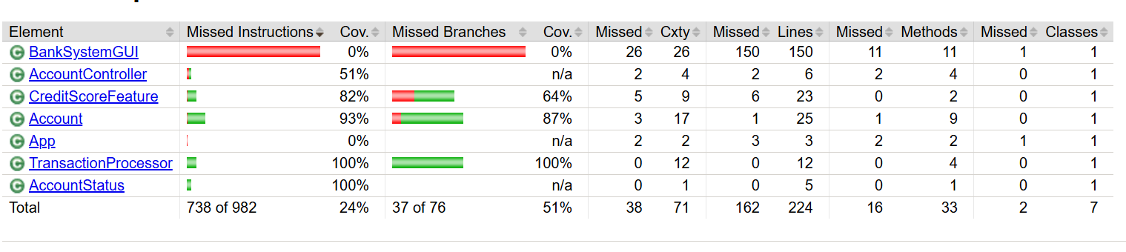

Observations:
- Excellent coverage:
- TransactionProcessor and Account methods are almost fully covered (93–100%).
- Ensures all main branches and edge cases are tested.
- Partial coverage:
- CreditScoreFeature ~82% – could add tests for rare cases (e.g., extremely high/low scores).
- AccountController ~50% – only backend logic tested, GUI → Controller flows not fully automated.
- Expected low coverage:
- BankSystemGUI and App have low or zero coverage.
- JaCoCo does not count GUI event-driven code executed outside of unit tests.
- GUI testing is handled via UITestChecklist.xlsx and UIBugList.docx instead.

